Web Programming Design Documentation AT1.6

30003389 – Kyer Potts

# Prototype

### Index

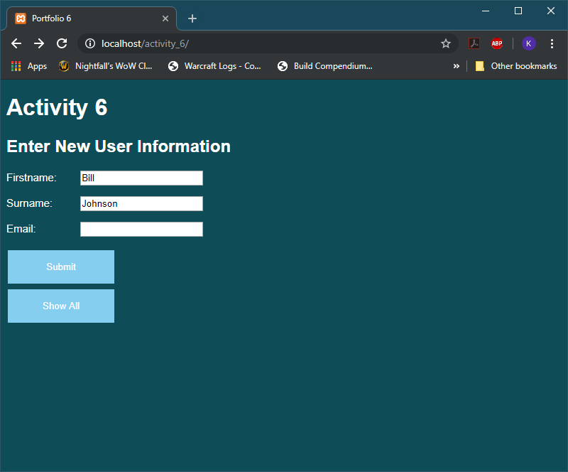

### Add user

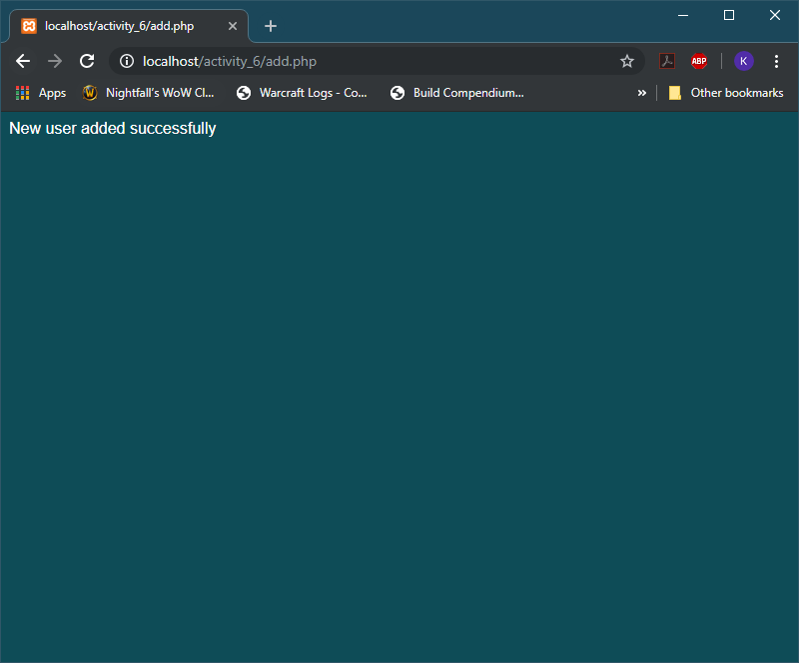

### Add user with incorrect details

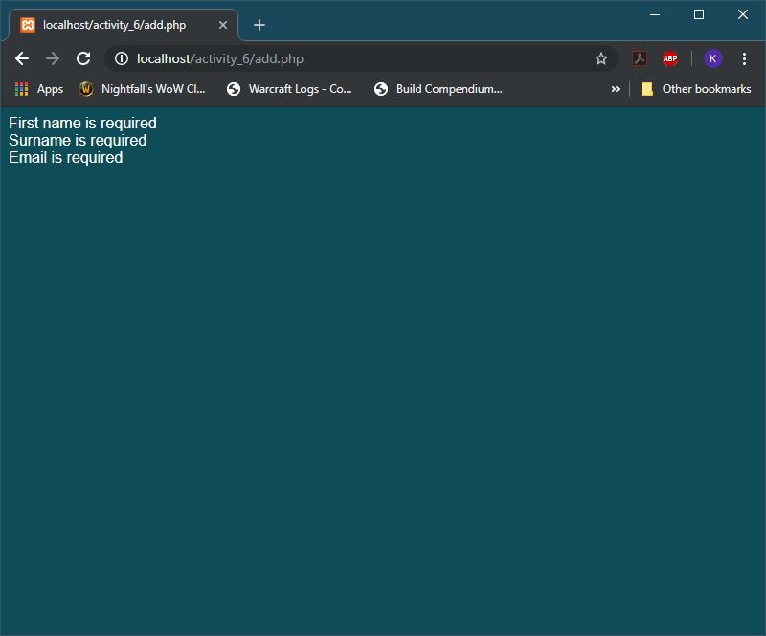

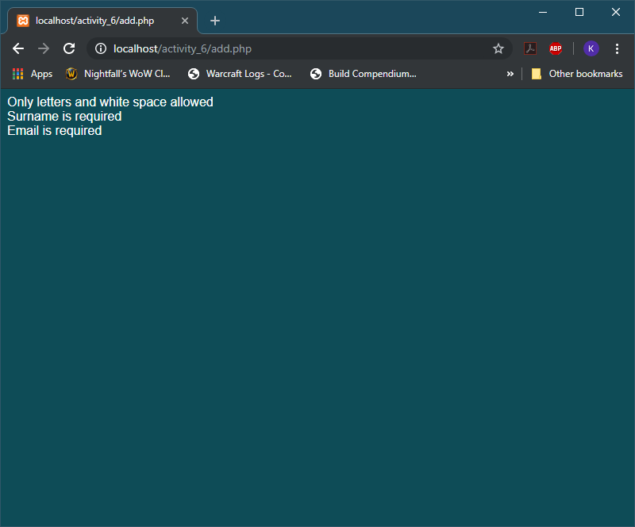

### Show all users

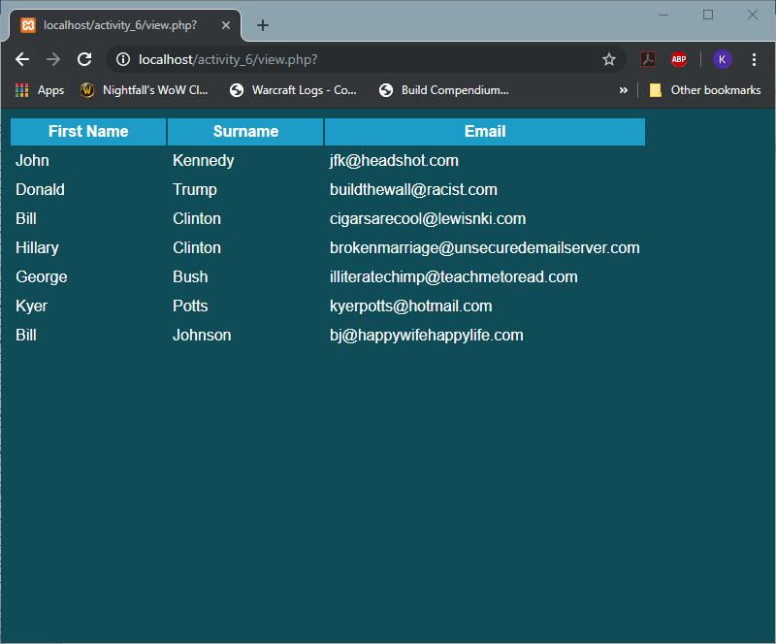

# Functional Design and Architectural Requirements

The website works with a combination of html, php and css elements, combined to achieve a pleasant look and feel while navigating member lists and adding new users to the database. The design is complete and achieves all desired outcomes

# Brief Purpose of the Website and its Required Functionality

The purpose of this website is to add users to a database, and to query the database to show all current members that have been added. The website also needs to validate and check all information before adding it to the database.

# Target System of the Application

The website was designed to run in any internet browser capable of displaying html code. It was developed using the google chrome browser as default, however it will also run without issues on Mozilla Firefox and Internet Explorer. Further testing is required to ensure that it works on Safari.

# Data Storage Design

The database is called names_emails and contains only one table with four fields.

* id – auto increments and does not require input from end users
* firstname – data will need to be entered into the database by end users
* surname – data will need to be entered into the database by end users
* email – data will need to be entered into the database by end users

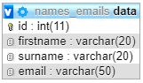

### SQL dump to generate new database with dummy users

CREATE database names_emails;

USE names_emails;

CREATE TABLE `data` (

`id` int(11) NOT NULL AUTO_INCREMENT,

`firstname` varchar(20) NOT NULL,

`surname` varchar(20) NOT NULL,

`email` varchar(50) NOT NULL,

PRIMARY KEY (id)

);

INSERT INTO data(`firstname`,`surname`,`email`) VALUES

("John", "Kennedy", "jfk@headshot.com"),

("Donald", "Trump", "buildthewall@racist.com"),

("Bill", "Clinton", "cigarsarecool@lewisnki.com"),

("Hillary", "Clinton", "brokenmarriage@unsecuredemailserver.com"),

("George", "Bush", "illiteratechimp@teachmetoread.com")